POLYNOMIAL REGRESSION:
Polynomial Regression is a regression algorithm that models the relationship between a dependent(y) and independent variable(x) as nth degree polynomial. The Polynomial Regression equation is given below:
y= b0+b1x1+ b2x12+ b2x13+...... bnx1n
It is a linear model with some modification in order to increase the accuracy.The dataset used in Polynomial regression for training is of non-linear nature
If we apply a linear model on a linear dataset, then it provides us a good result as we have seen in Simple Linear Regression, but if we apply the same model without any modification on a non-linear dataset, then it will produce a drastic output. Due to which loss function will increase, the error rate will be high, and accuracy will be decreased.
So for such cases, where data points are arranged in a non-linear fashion, we need the Polynomial Regression model. Eg:
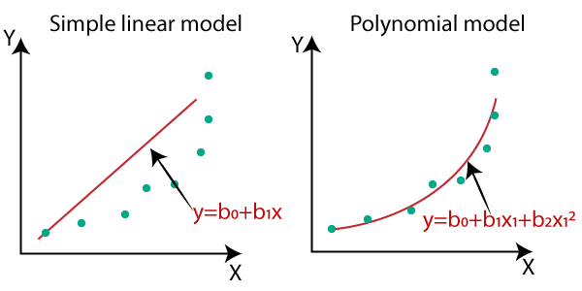

straight line is unable to capture the patterns in the data. This is an example of under-fitting.
To overcome under-fitting, we need to increase the complexity of the model.
To generate a higher order equation we can add powers of the original features as new features. The linear model,
can be transformed to

To convert the original features into their higher order terms we will use the PolynomialFeatures class provided by scikit-learn.
To prevent over-fitting, we can add more training samples so that the algorithm doesn’t learn the noise in the system and can become more generalized.

The above algebraic method works best for small number and one degree polynomials but for higher degree polynomials we will be using matrices and linear algebra.

MULTIVARIATE LINEAR REGRESSION
Multiple linear regression attempts to model the relationship between two or more explanatory variables and a response variable by fitting a linear equation to observed data. Every value of the independent variable x is associated with a value of the dependent variable y. The population regression line for p explanatory variables x1, x2, ... , xp is defined

Where:
β0 is the constant term and
β1 to βp are the coefficients relating the p explanatory variables to the variables of interest.

In terms of a hypothesis test, for the case of a simple linear regression the null hypothesis, H0 is that the coefficient relating the explanatory (x) variable to the dependent (y) variable is 0. In other words that there is no relationship between the explanatory variable and the dependent variable. The alternative hypothesis H1 is that the coefficient relating the x variable to the y variable is not equal to zero. In other words there is some kind of relationship between x and y.

